**Task 18: Creating DynamoDB Tables and Configuring IAM Role for EC2 Access**

**AWS DynamoDB**

Amazon DynamoDB is a fully managed NoSQL database service provided by Amazon Web Services (AWS) that offers high performance and scalability for applications requiring consistent, low-latency data access. It supports both key-value and document data models, allowing for flexible data storage and retrieval, while automatically managing scaling, replication, and backup to ensure data durability and availability.

**NoSQL Database**

A NoSQL database is a type of database management system that stores and retrieves data in a non-tabular format, allowing for flexible schemas and scalability. It supports various data models, such as key-value, document, column-family, and graph, making it suitable for handling large volumes of unstructured or semi-structured data in real-time applications.

1. Created two Tables in AWS DynamoDB

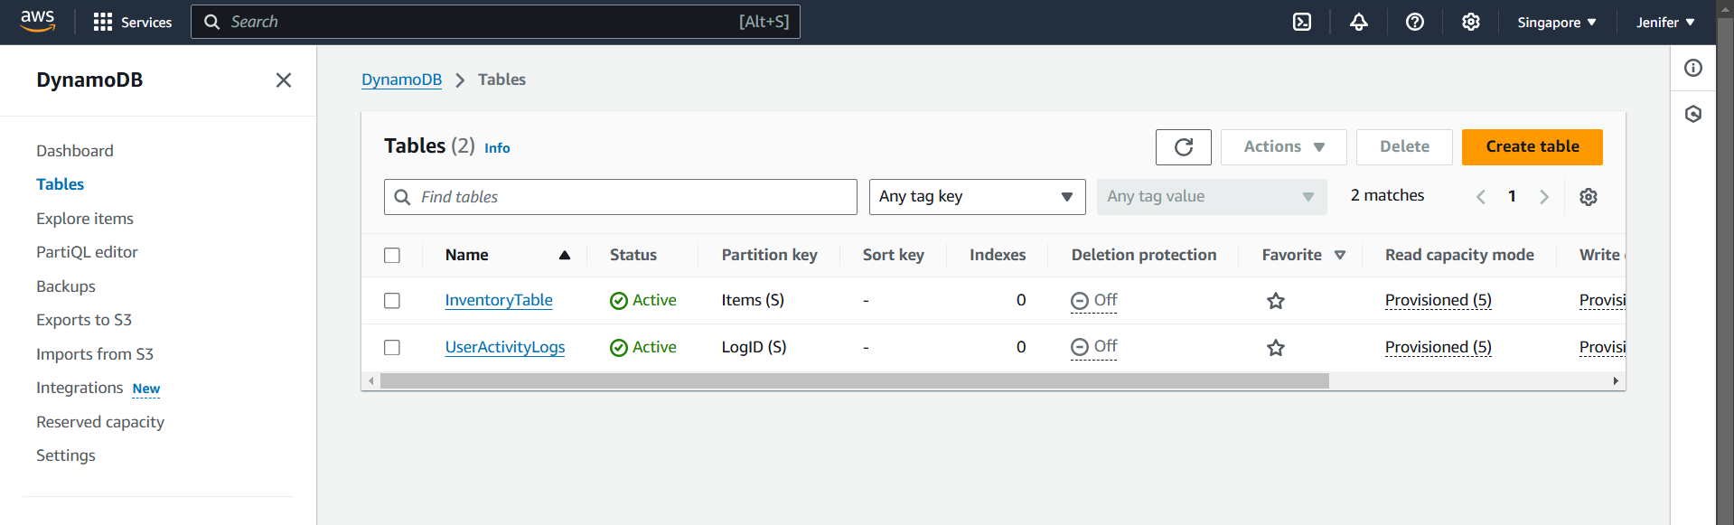

1. Items Returned in each Table

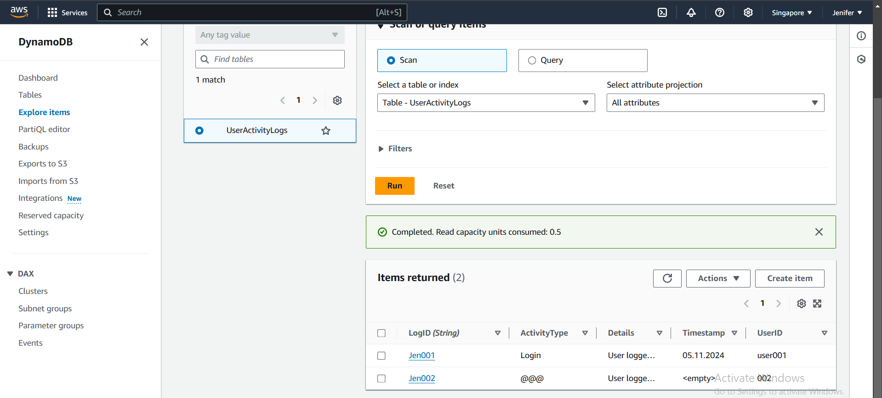

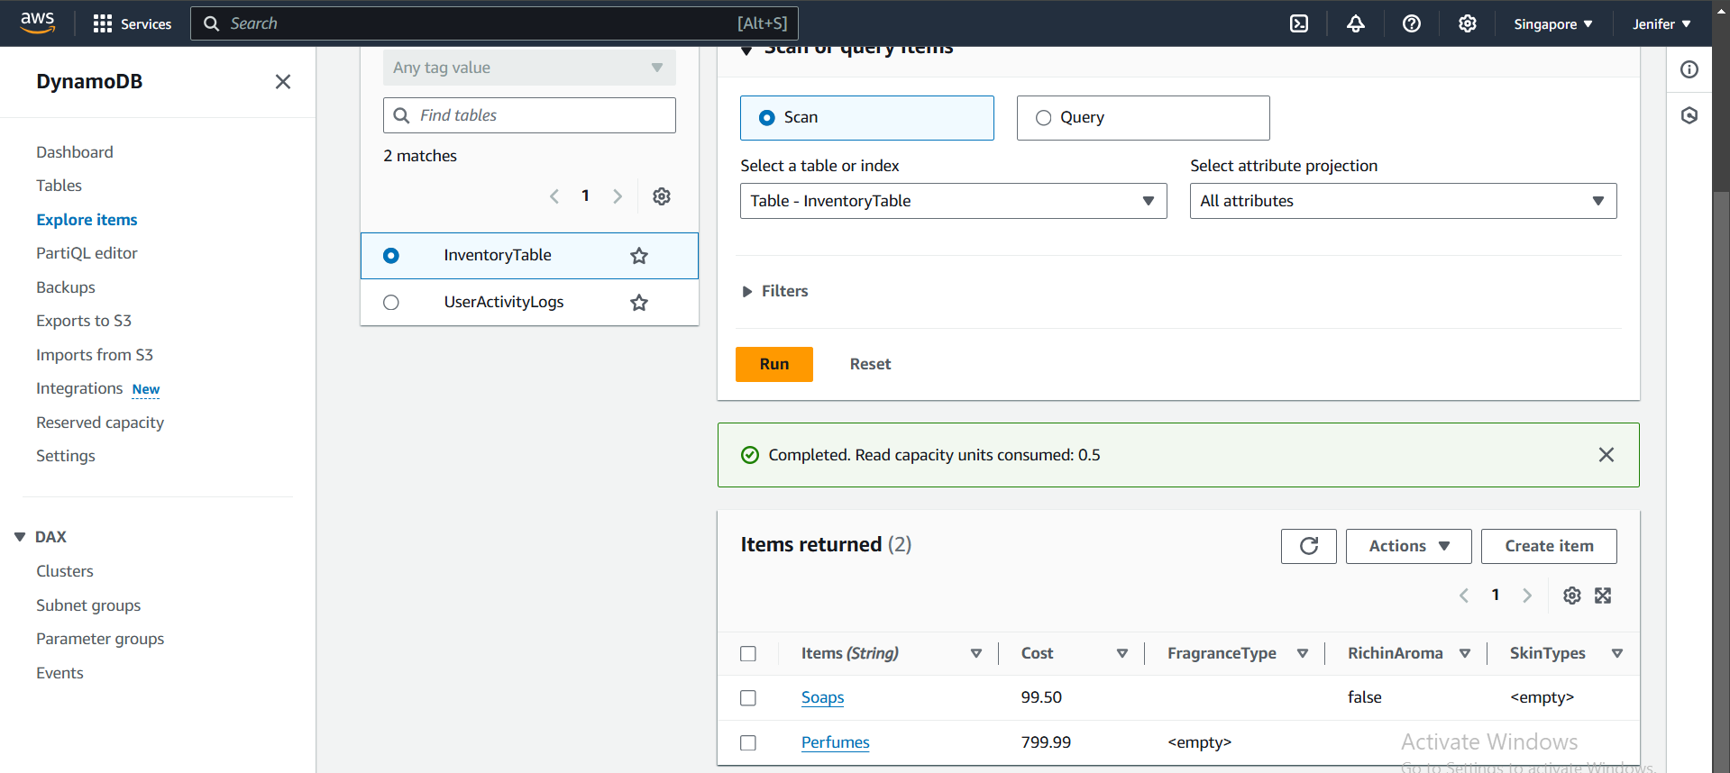

1. JSON View of Explore Items: UserActivityLogs Table

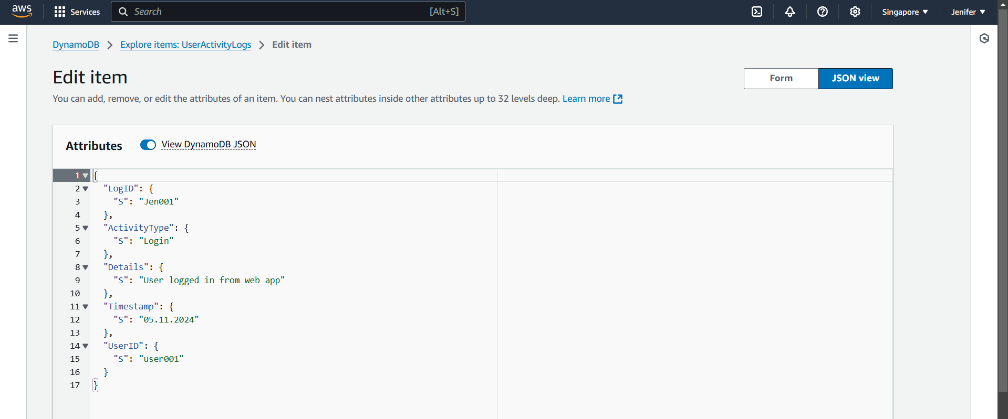

1. Created an EC2 Instance named DynamoDB

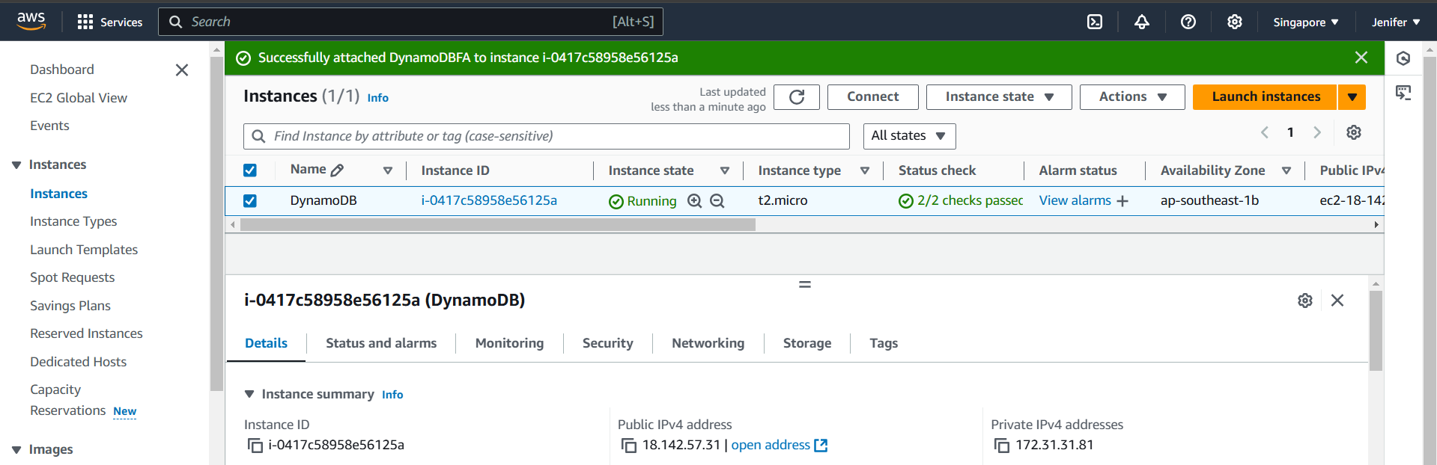

**AWS IAM Role**

An IAM Role (Identity and Access Management Role) in AWS is a set of permissions that allows services or users to access AWS resources temporarily without needing permanent credentials. It enables secure management of permissions for tasks that require specific access rights.

1. Created an IAM Role(DynamoDB Full Access) for the EC2 Instance to Access DynamoDB

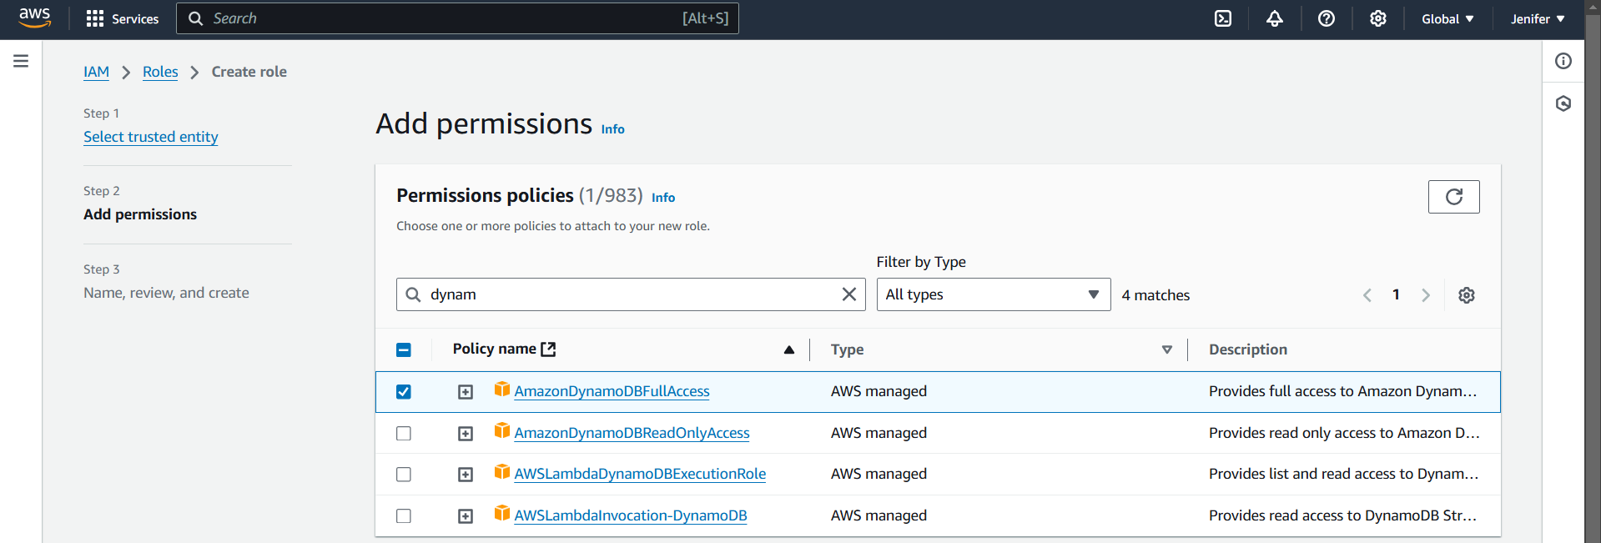

**AWS CLI**

AWS CLI (Amazon Web Services Command Line Interface) is a unified tool that allows users to interact with AWS services using command-line commands. It provides a way to automate tasks and manage AWS resources through scripts or commands, making it easier to perform operations without needing to use the AWS Management Console.

1. Logged into the EC2 Instance and Installed AWS CLI

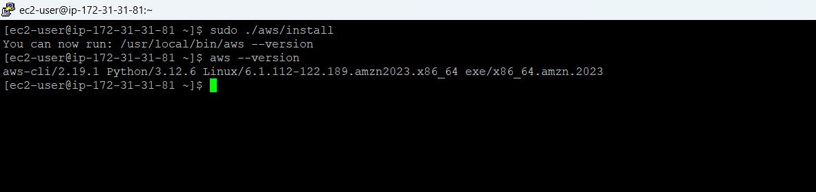

1. The Tables which are created in DynamoDB are successfully reflected in my EC2 Instance using the command **“aws dynamodb list-tables”**

